**Business Requirements Document**

**1.0 Background and Problem Statement**

Smithgall Woods is a state park in Helen, Georgia where attendees of the park can partake in recreational activities such as fishing, hiking, camping, and volunteering. Smithgall Woods obtains return volunteer hours from the state which gives an incentive for Friends chapters to volunteer their time so that the park itself can get more state money. The Smithgall Woods site should have the capability for volunteers to be able to log their hours in an easy to use interface. Another large concern that the park has is security and maintenance of the site. However, no specifications of what was preferred by the park was ever distinguished. It is understood that updating the site content is complex to the administrator and that it becomes difficult to change things. Most recently, the site has been hacked with “Cialis” links dispersed throughout the site.

1. **Business Requirements**

**2.1 Requirements Breakdown**

* User manual and training documents to be utilized by the Smithgall Woods team and website admins
* Potentially switch over to Java programming language
* User friendly interface
* Website mobility usage
* Pictures: Smithgall Woods wants to connect to the state site to rent cabins, along with includingpictures of cabins and highlighting volunteers
* MySQL language

**2.2 User Requirements**

The team recommends the following user requirements and will prioritize them from high to low before defining the system requirements. The prioritized list of requirements will be described in sufficient details under Functional Specifications (System Requirements) in Section 3.0.

A. Website Pages (Site navigation & content presentation)

**Requirement #1**: Smithgall Woods website shall be designed with user-friendly navigation that allows users to find information quickly through logical menu structure.

**Requirement #2**: Smithgall Woods website content of each page shall be arranged in a way to improve its appearance and make it interesting to existing users and future visitors to the site.

B. Become a Friend or Volunteer Page

**Requirement #1**: The page shall have more detailed information about becoming a friend or volunteer including directions, volunteer training day information, and working hyperlinks.

**Requirement #2**: All hyperlinks shall be active, correct, and current.

C. Cottage Accommodations Page

**Requirement #1**: Smithgall Woods cottage accommodations page shall link directly to the relevant state parks reservations page.

**Requirement #2**: Smithgall Woods cottage accommodations page shall be renamed to Reservations and list group (pioneer) camping and picnic shelter information, which are reserved through the same link.

D. Volunteer Hours Log Page with Mobile Capability

**Requirement #1**: Smithgall Woods application shall validate volunteers, jobs and hours by authentication process.

**Requirement #2**: Smithgall Woods application shall be formatted with mobile devices in mind so that logging data via mobile is userfriendly.

E. Volunteer Report Generator Page with Separate Login

**Requirement #1**: Smithgall Woods application shall generate volunteer reports showing the number of volunteer hours.

**Requirement #2**: Smithgall Woods application shall be capable of setting up user access to Report Generator for designated individuals only.

Home Page Mockup (Desktop Version)

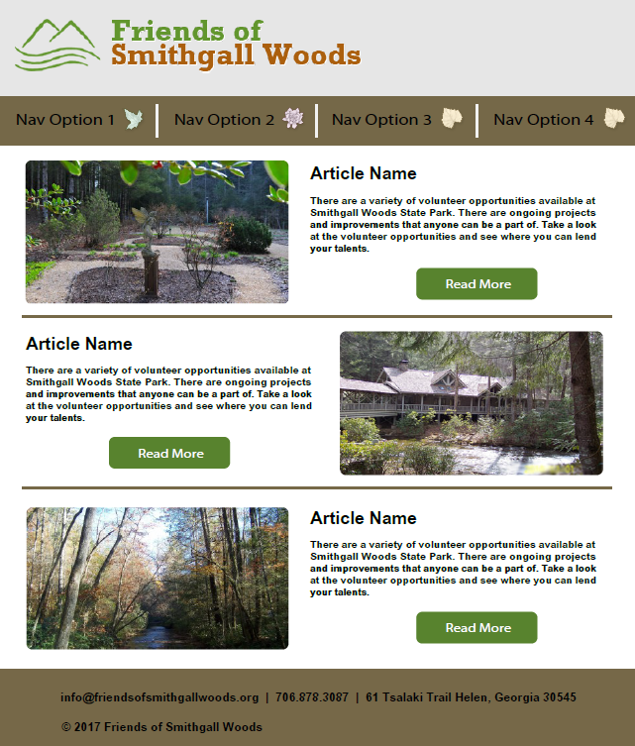

Home Page Mockup (Mobile Version)

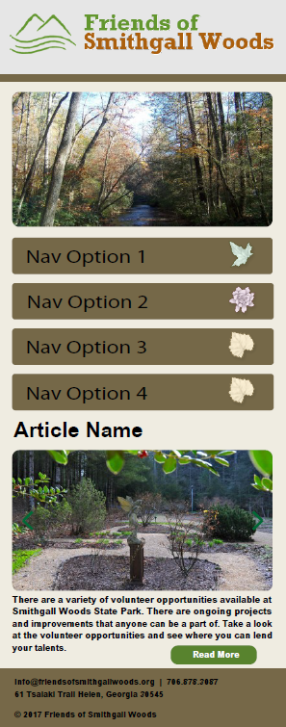

**3.0 Functional Specifications**

N/A for right now—will add one as we get more detail around requirements

**4.0 Discoveries**

* **Existence of unnecessary accounts: Some of the following accounts may be able to be removed if the Friends of Smithgall Woods agree they are unnecessary.**

**Note**: Since this document is available through GitHub and visible to the public, the passwords for the following login accounts were left off from this document for security reasons. However, these passwords are safely stored in another document and can be retrieved as needed.

* + Hosting site
    - 17505820 – Dr. Huber’s account
  + Databases
    - [db357026991](https://my.1and1.com/mysql-database-details/db357026991?__lf=ftp_create_account_flow) (FSGW)
    - [db358933030](https://my.1and1.com/mysql-database-details/db358933030?__lf=ftp_create_account_flow) (FSGWData); Database for Volunteer Hours
    - [db360322876](https://my.1and1.com/mysql-database-details/db360322876?__lf=ftp_create_account_flow) (Fresh root WP install): This is the database the WordPress site pulls from and saves to for page content.
    - [db265662256](https://my.1and1.com/mysql-database-details/db265662256?__lf=ftp_create_account_flow) (login and hours database): We think this is the volunteer hours db.
    - [db268336715](https://my.1and1.com/mysql-database-details/db268336715?__lf=ftp_create_account_flow) (calendardb)
  + FTP accounts
    - [u48922589](https://my.1and1.com/ftp-account-details/54939311?__lf=ftp_create_account_flow)
    - [u48922589-drdan](https://my.1and1.com/ftp-account-details/75464305?__lf=ftp_create_account_flow) : This is the only account we can access. The passwords for the others are incorrect. We only need one account, so we propose getting rid of the remaining
    - [u48922589-students](https://my.1and1.com/ftp-account-details/76946453?__lf=ftp_create_account_flow)
    - [u48922589-Admin](https://my.1and1.com/ftp-account-details/77483152?__lf=ftp_create_account_flow)
  + WordPress accounts
    - mhuber ([mhuber@uga.edu](mailto:mhuber@uga.edu))
    - admin ([youdomaincom977@gmail.com](mailto:youdomaincom977@gmail.com)) : this is the default admin name in WP and we suggest that it should be changed via the wp_users table in the database, assuming that nothing becomes disrupted
    - Admin1 ([webmaster@friendsofsmithgallwoods.org](mailto:webmaster@friendsofsmithgallwoods.org))
    - lcompton ([compton.pl@gmail.com](mailto:compton.pl@gmail.com)) : Web Committee Leader
* **Outdated Plugins**
  + WordPress – Running version 4.5.9🡪update to 4.8.1
  + PHP – Running version 5.2🡪update to 7.0
  + WordPress theme – No update found
  + WordPress plugins
    - Akismet – Running version 3.0🡪update to 3.3.4
    - NextGEN Gallery – Running version 1.7.4🡪update to 2.2.12
    - Page Links To – Running version 2.4🡪update to 2.9.9
    - Seo Meta Tags – Running version 1.0🡪update to 1.4
* **Hidden Link Injection:**
  + A hidden link injection in WordPress is when the attacker inserts links into the files of active WordPress themes and are typically wrapped in HTML comments. It is believed that this is what is pointing to the “Cialis” site. This is a common problem in WordPress versions 2.8x and attackers are able to get into the \wp-admin\upload.php file and insert files on the server
  + A base64_decode on the second line of the \wp-includes\locale.php file was found and identified as part of the injected malicious code that triggers the “cialis” messages with external web links to be displayed in multiple site pages.

**5.0 Proposed Solutions to Security Vulnerability**

* Deleting the malicious html insert from the file
  + Note: Commenting the injected code out prevents the “Cialis” messages with hyperlinks from being displayed throughout the site
* Updating plugins and software to suggested versions found in **“Discoveries”** section
* Removing unnecessary accounts as suggested in **“Discoveries”** section
* Changing the passwords for all remaining accounts.
* Considering other programming languages that are more robust. Recommend using Java and JavaScript for rebuilding the site
* Use the hosting website’s security application to help prevent further issues.
  + 1&1 SiteLock - <https://help.1and1.com/hosting-c37630/sitelock-c85170/what-is-1and1-sitelock-a792625.html>
    - Basic ($.99/month)
      * Daily malware scan
      * Trust Seal
      * Search engine blacklist monitoring
      * SSL verification
      * Web app scan (on demand once a month)
      * SQL injection scan (on demand once a month)
      * XSS scan (on demand once a month)
      * Number of pages monitored – 25
    - Premium ($4.99/month)
      * Daily malware scan
      * Trust Seal
      * Search engine blacklist monitoring
      * SSL verification
      * Web app scan
      * SQL injection scan
      * XSS scan
      * File Change Monitoring
      * Number of pages monitored – 500